Name:Enter Your name here Target for this cycle 1.3
Types of Network

What is a network?
Notes Here.
What do we use networks for?
Explain the different network types (ranges)
PAN

LAN
.
WAN
Notes Here.
Client Server Vs Peer to Peer
Client Server
Notes Here.
Peer to Peer
Notes Here.
Comparision

Other Notes or Activities
State whether the statements are client server or peer to peer
More suitable for small number of computers
All data can be backed up centrally
Through sharing rights any computer can share the programs of another
All data is stored on the individual computers of the network
Users have to log into the network through a central computer
Network Security is distributed to the individual compters
Cheaper to set up and maintain

Exam Questions
 | 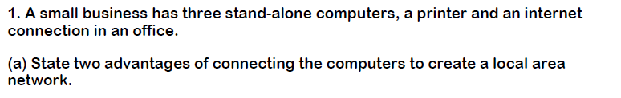 | Difficulty
ANSWER -
Insert Answer Here

 | 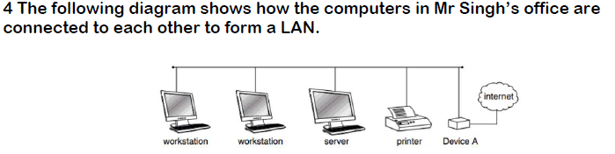
ANSWER -
Insert Answer

How have you found this section? | Understand Totally
A reminder: Hardware are the physical elements that make up a computer system

The Hardware Needed
List the different hardware needed to run a network.
Independent research based task. Take each item from the list and find out as much as possible about it. (Add relevent image)
Network Interface Card.
Notes Here.
Switch (HUB)
Wireless Access Point
Router
Notes Here.

Transmisson Media (Ethernet and Radio Waves) 5
Notes Here.
Task: Drag the blue boxes to the correct descriptions.
Hub
Wireless Access Point (WAP)
Network Interface Card (NIC)
Router
Switch

Exam Questions
Difficulty
ANSWER -
Insert Answer

ANSWER -
Insert Answer

How have you found this section? | Understand Totally

What is the internet?
Hosting
Addresses.
Domain Names
Notes Here.
DNS
Notes Here.

Packets
The Cloud
Advantages | Disadvantages

Virtual Networks.
VN

Other Notes or Activities
Order the statements: IP and DNS
1
2

3
4

5
6

Exam Questions
 | 4 | Difficulty
ANSWER -
Insert Answer
 | 6 Mark Question; Quality of written communication will be assessed.
ANSWER -
Insert Answer

How have you found this section? | Understand Totally

