Target for this cycle Choose an item.
Name: Click here to enter text.
Representing Text
What does ASCII stand for?
What is ASCII used for, explain how ASCII works.
What is a character set? Find an imageof ASCII’s character set
Breaking the code!
What is your name in binary?
ASCII is a code for representing English characters as numbers. Convert the following!

Lovelace
65 83 67 73 73 32 105 115 32 97 32 99 111 100 101 32 102 111 114 32 114 101 112 114 101 115 101 110 116 105 110 103 32 69 110 103 108 105 115 104 32 99 104 97 114 97 99 116 101 114 115 32 97 115 32 110 117 109 98 101 114 115

Turing
65 83 67 73 73 32 109 97 107 101 115 32 105 116 32 112 111 115 115 105 98 108 101 32 116 111 32 116 114 97 110 115 102 101 114 32 100 97 116 97 32 102 114 111 109 32 111 110 101 32 99 111 109 112 117 116 101 114 32 116 111 32 97 110 111 116 104 101 114 4

Exam Questions:
Assessment

 | 3
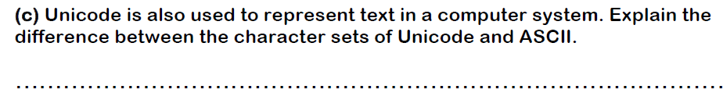 | 3
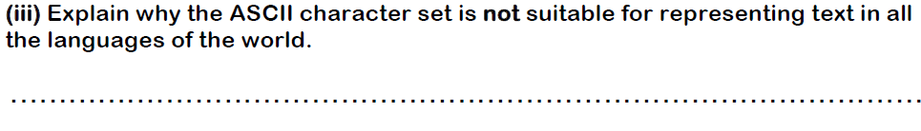 | 2

Representing Images-
You will need to download the excel image sheet from. www.computingsouthshields.com
What is a pixel?
Explain resolution, how does it impact on quality? | How does resolution impact of file size?
How does colour depth impact on quality?
What is a bitmap?
Draw an 8 x 8 image AND 16 X 16 image.
Calculate the size of the images.

Assessment

 | 2
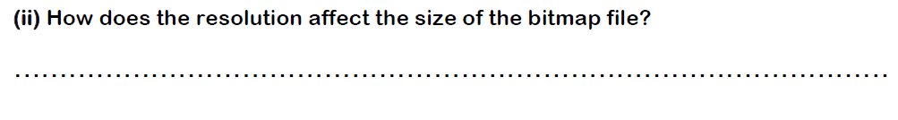 | 2

Sound
Define the terms analogue and sampling
Complete the following questions
- Explain how an analogue recording is made.
.

- Why doesn’t a digital recording of a piece of music contain all of the sound available?

.

- Explain what is meant by the ‘sample rate’.

.

- What sample rate is standard for audio CDs?
.

- What is meant by the ‘bit depth’ and how does it affect the quality of the digital recording?

Explain this image!

Assessment

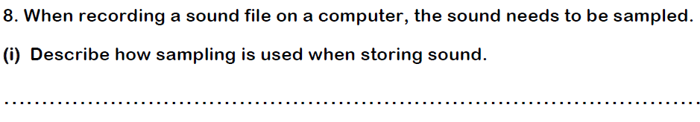 | 2
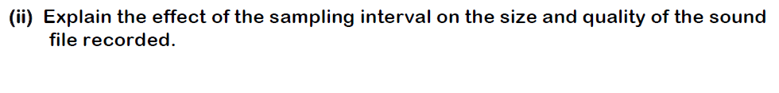 | 2

Compression
Define the term compression
Why is file compression important?
What is the difference between lossless and lossy compression?
Complete the following question and table-Zuckerberg
- This compression method is most commonly used to compress image, audio and video files:
- Highlight the correct compression method associated with the file types below:

File type | Lossy | Lossless
JPEG
GIF
MP3
PNG

Complete the following table –Love lace
Type | File Type | Compression Type | Explanation
Bitmap
JPEG  Joint Photographic Experts Group | .jpg | Lossy | Good for photographs.  Colour depth = 24 bits, RGB 16.7 million different colours.
GIF
Graphic Interchange Format

Complete the following table-Turin

Type | File Type | Compression Type | Explanation
Bitmap | .bmp | -
JPEG  Joint Photographic Experts Group | .jpg
GIF  Graphic Interchange Format | .gif | Lossless
MP3 | .mp3 | Lossy
PNG  Portable Network Graphics | .png
PDF  Portable Document Format | .pdf | Supports both Lossy and Lossless compression

Lossless – Run Length Encoding.
Lossless – Huffman Encoding
Examples

Assessment

Files are often compressed so that they can be sent over the internet:  State what is mean by compression | 1
HELEN FEEDS THE EELS, Use both the Huffman code and ASCII to calculate the amount of bits. Compare and contrast them. | 6

