9.2 Are you ready? Assessment

Teacher Help (teacher use)
5. Constant Help | 4 | 3 | 2 | - Independent
☐ | ☐ | ☐ | ☐ | ☐

Scenario
Mrs Maddock wants to create an automatic maths quiz to test year 7s ability to Add, Subtract and Multiply. The program should ask the user their full name. The program will need to ask exactly 10 questions that are randomly generated. If the question is answered correctly the program will add one to score and let the user know they are correct. If the answer is not correct the student will be told they are incorrect. At the end of the quiz the program should tell the user their score out of 10.
You will need to analyse, design (flowchart) and program the quiz
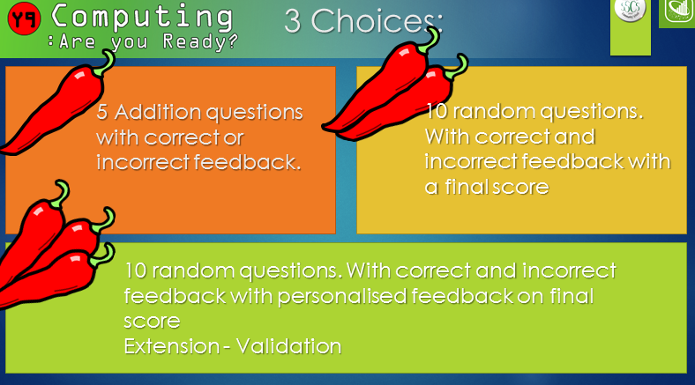
Which Chilli did you choose to attempt?
☐ | ☐ | ☐

Analysis
To be successful my program will need to include or do:
- A variable to hold user input for their name
- Click here to enter text.
- Click here to enter text.
- Click here to enter text.
- Click here to enter text.
- Click here to enter text.
- Click here to enter text.
- Click here to enter text.
- Click here to enter text.
- Click here to enter text.
- Click here to enter text.
- Click here to enter text.

Flowchart (Copy and Paste algorithm from Inspiration8)

Development

