Name:Enter Your name here

What is an operating system?
Notes Here.

Examples?
Notes Here.

What does an operating system do
Notes Here.

How have you found this section? | Partially Understand

Difficulty
Insert Answer

Other Activities

User interface
User interface.
Notes Here.

Ease of use examples
Notes Here.

How have you found this section? | Found it a challenge

User interface examples

Menu Driven
Notes Here.

Command Line Interface (CLI)
Notes Here.

GUI
Notes Here.

How have you found this section? | Partially Understand

Operating system roles

Memory Management
Notes Here.

Peripheral Management
Notes Here.

Multi- Tasking
Notes Here.

How have you found this section? | Partially Understand

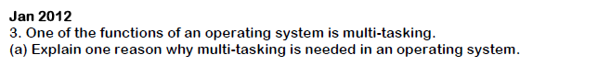
Insert Answer

Other Activities

Utility program investigation
3 main reasons for Utility Programs
Notes Here.

Deal with security risks..
Notes Here.

Defragmenting, disc cleaning and system maintenance.
Notes Here.

How have you found this section? | Partially Understand

 | 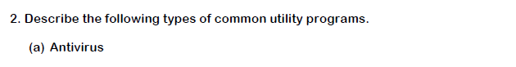  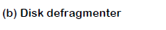 | Difficulty
 | Insert Answer
 | 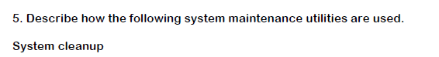
 | Insert Answer

Other Activities

Open Source
Notes Here.

Proprietary
Notes Here.

How have you found this section? | Partially Understand

Off the shelf
Notes Here.

Custom Written
Notes Here.

How have you found this section? | Partially Understand
Investigate – off the shelf/custom written

 | 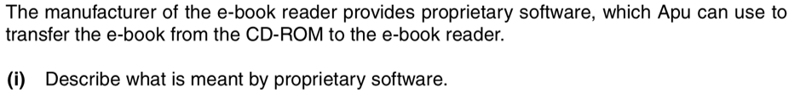 |  | Difficulty
 | Insert Answer
 | Insert Answer
 |  | 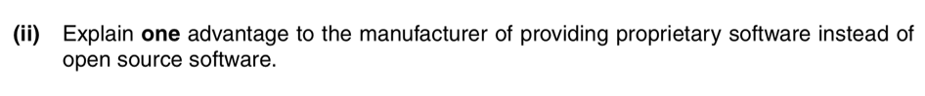 | Difficulty
 |  | Insert Answer

