**GCSE ICT – 6 mark question.**

Below are the 6 mark questions for the 2012, 2013 and 2014 papers. Each question has the mark scheme below.

Attempt the question and then mark it, identifying any areas for improvement.

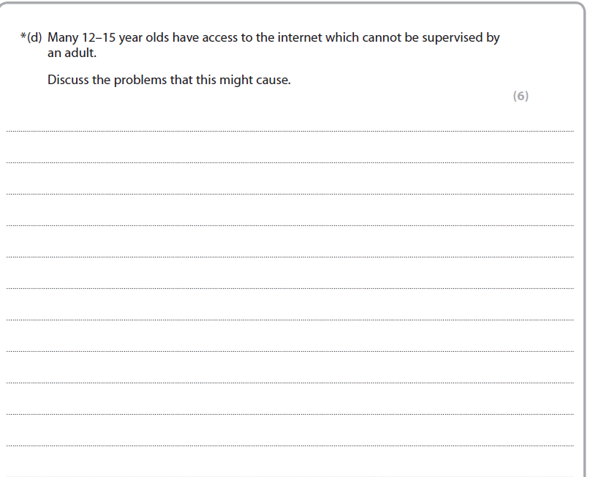

Tips box – Move this box if you need to see the tips, before attempting to answer the question.

Do not make vague statements like “bad things can happen”. You need to explain what you mean such as cyberbullying.

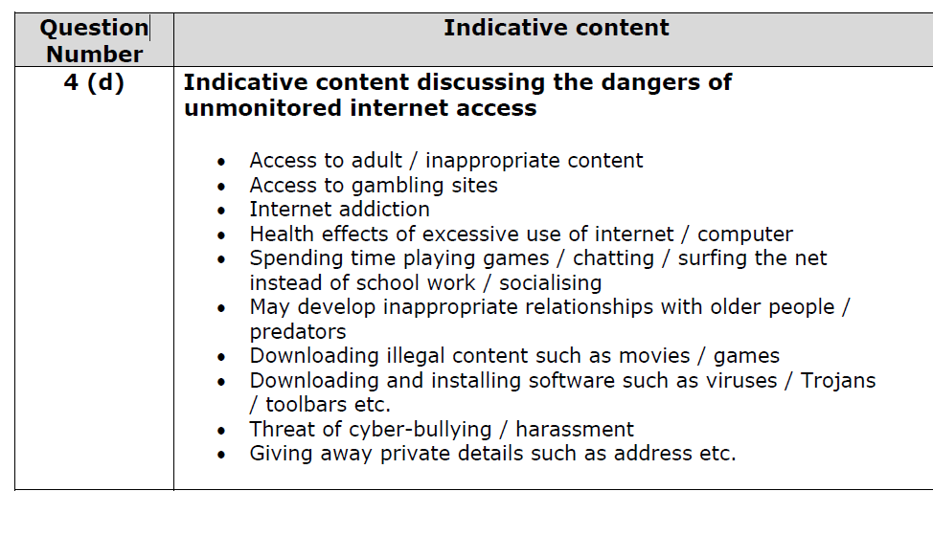

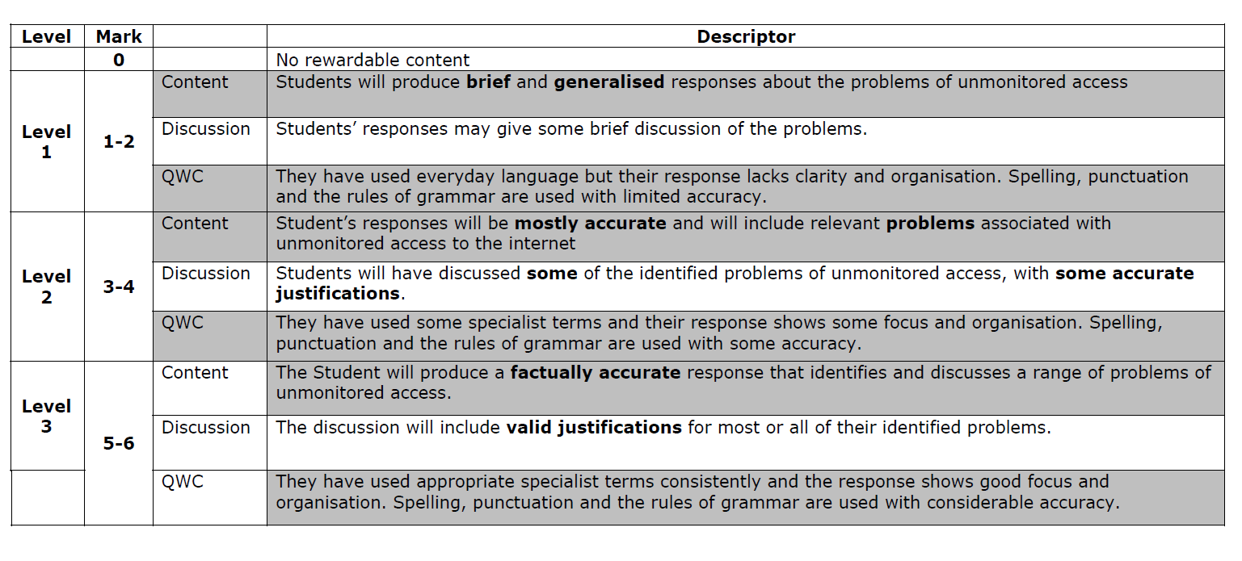

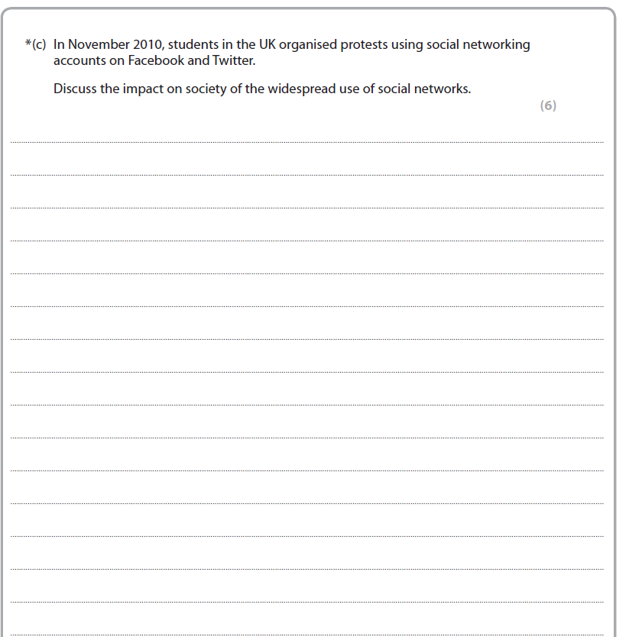

Tips box – Move this box if you need to see the tips, before attempting to answer the question.

The question need you to focus on society not the individual.

Therefore, how has social media been good or bad for society. What can people organise on social media that is good for groups of people/local community.

Also, consider what bad things can people organise on social media that is bad for society.

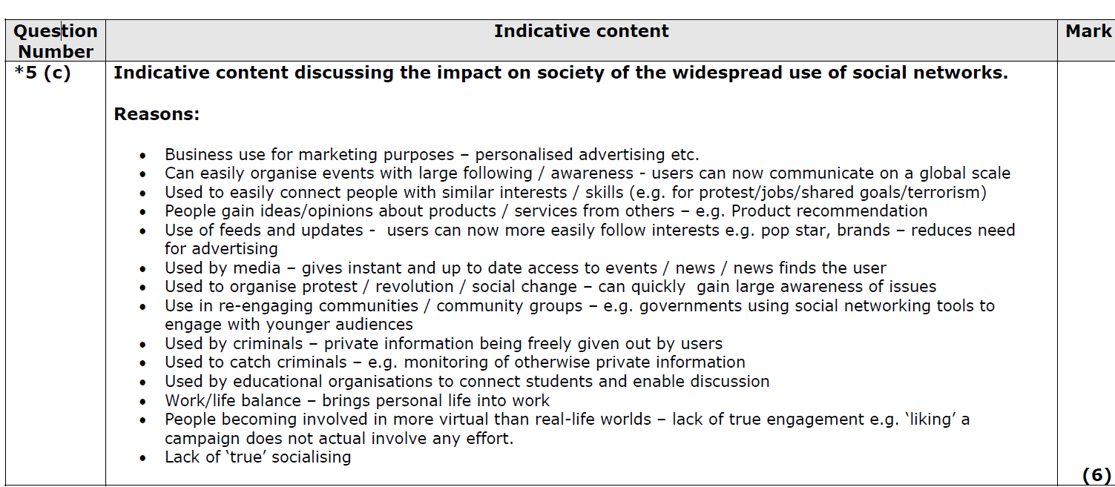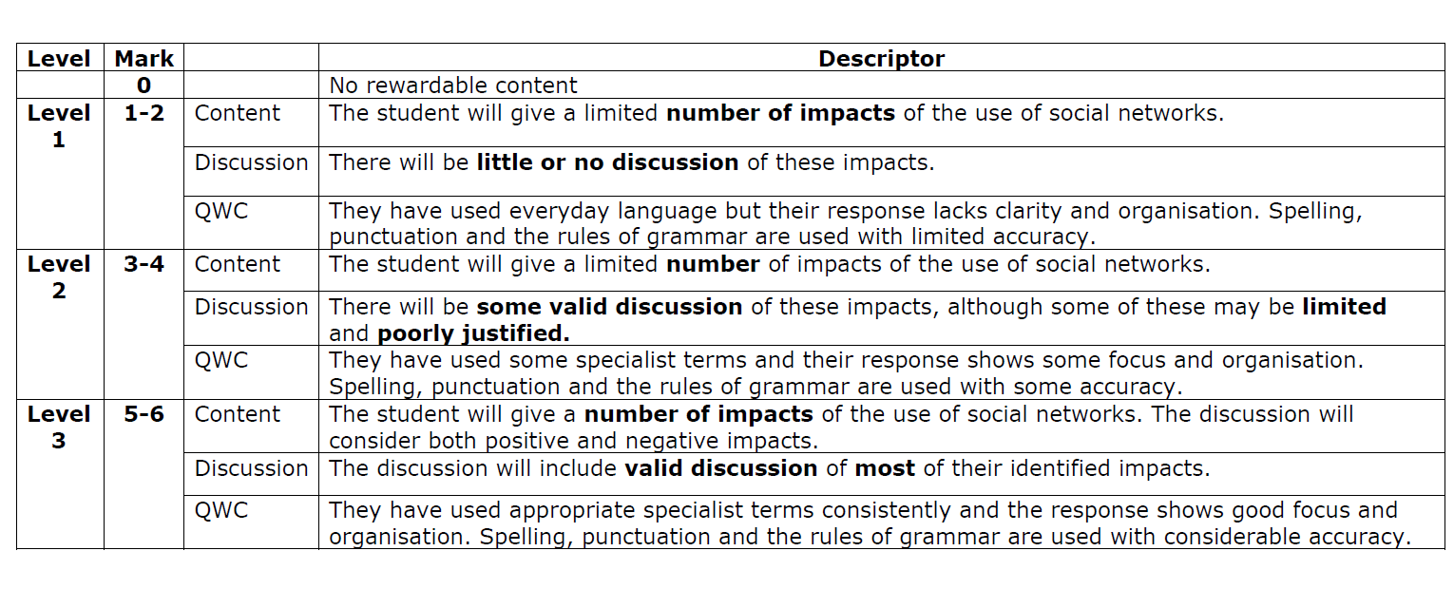

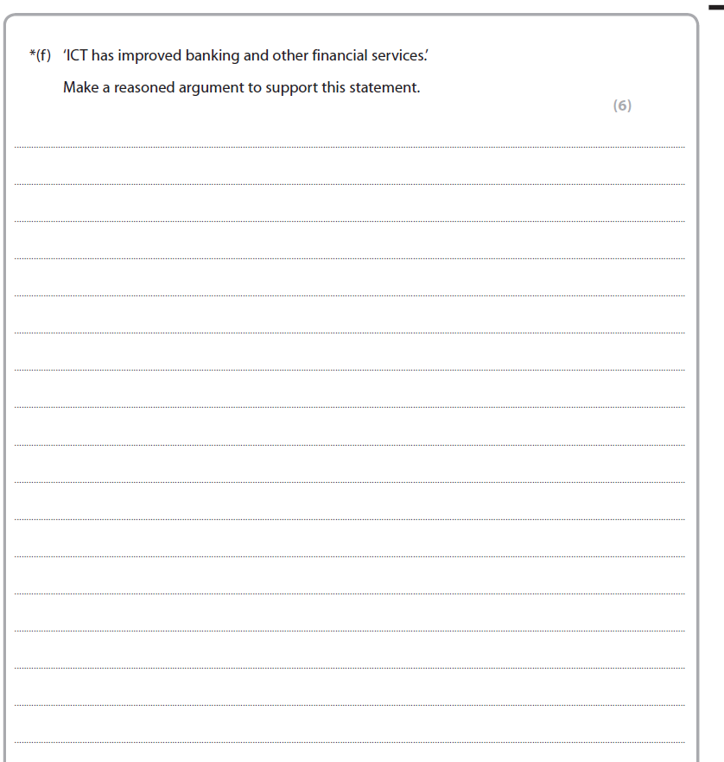

Tips box – Move this box if you need to see the tips, before attempting to answer the question.

Tips if required – other financial services include comparison websites. For this type of question you can talk about the advantages of online banking, telephone banking and the use of NFC.

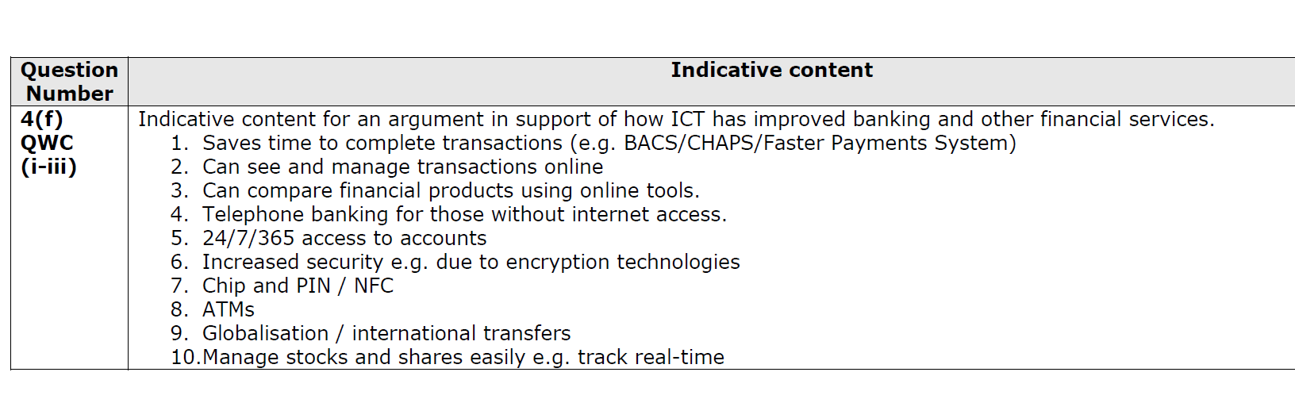

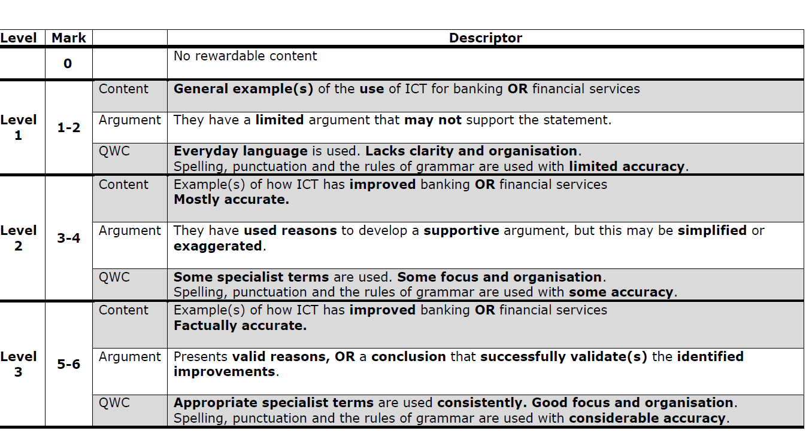

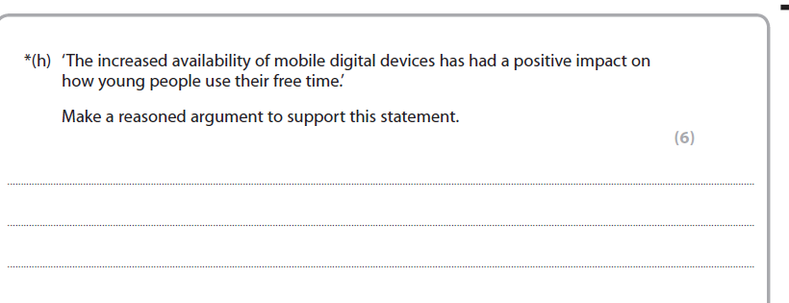

Tips box – Move this box if you need to see the tips, before attempting to answer the question.

This question only requires positives.

Think about how it can impact on

1. Social life
2. Entertainment

These are just 2 examples help you start your answer.

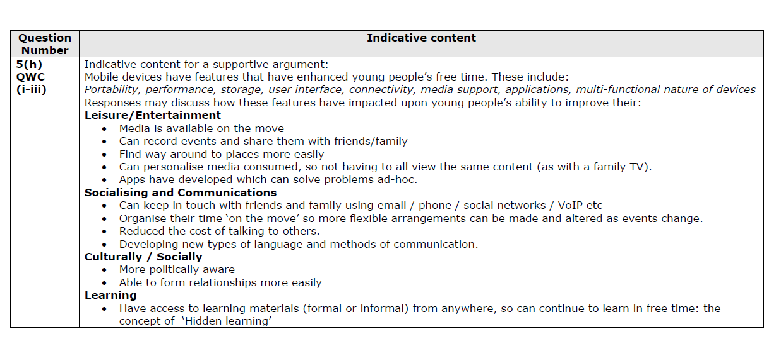

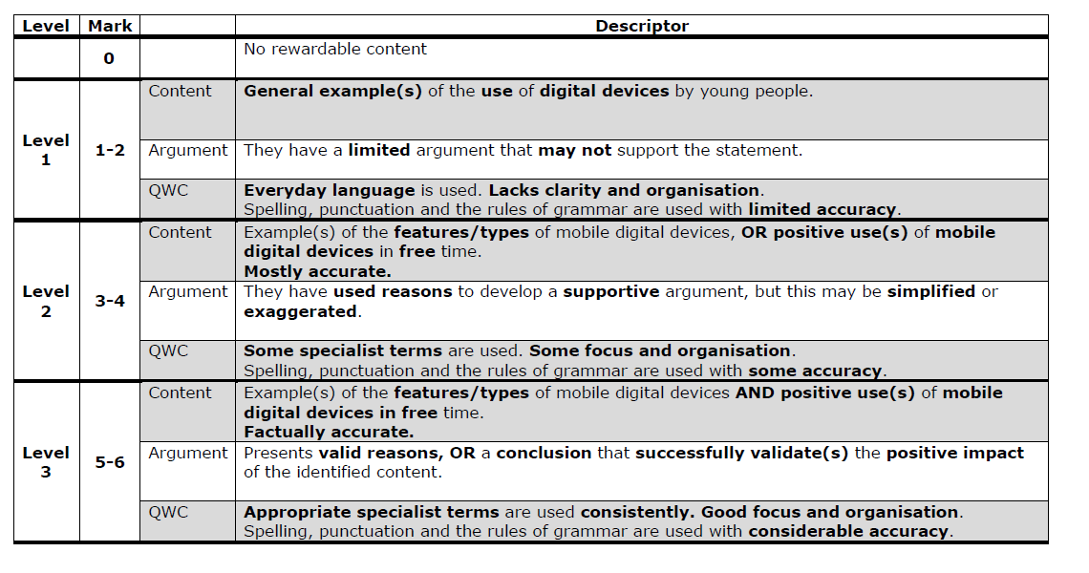

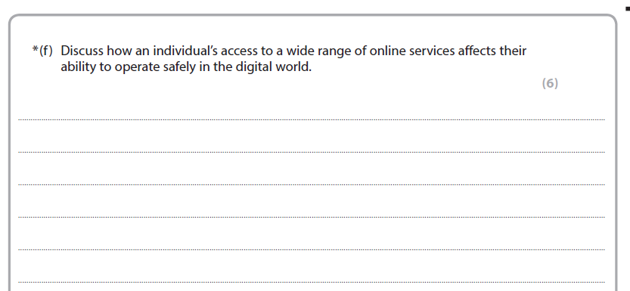

If you don’t know what an online service is, you will need to move this box to see the tip.

Examples of online services include:

Online gaming

Online gambling

Online banking

Online auctions

Select some of these and explain how they could impact on a person’s safety.

2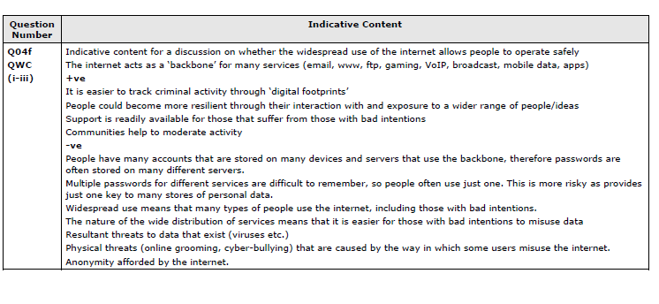

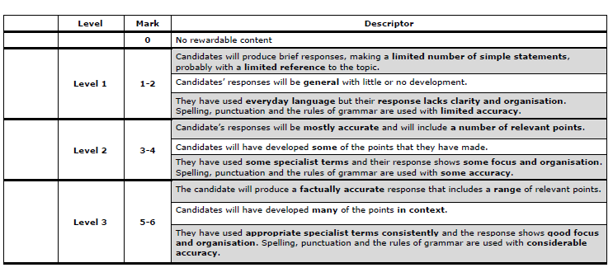

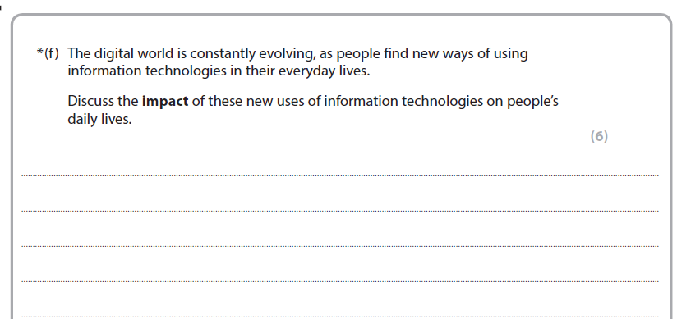

The key part of this question is to discuss **new uses of technology.**

So answering you can surf the internet or watch TV, would not be a new use.

Move this box for some ideas about new technology.

Examples include:

Wearable technology (fitness monitors, google glass, VR headsets etc)

3D printer.

Smart TV’s

Wireless chargers

Intelligent personal assistants (Google Home and Alexa)

Please be aware the mark scheme below is from 4 years ago so does not include 3D printers, wireless chargers and intelligent home assistants.

