KS4 Target Choose an item.
Name: Click here to enter text.
E-Safety-Stalking
What do you already know?  K | What do you wonder/not know?  W | What have you learned?  L | How did you learn?  H
What is E-safety
Define the term stalking
What are the dangers of stalking? | What impact does this have on individuals?
How can you prevent stalking from happening? | Where can you get help?

E-Safety-Grooming
What do you already know?  K | What do you wonder/not know?  W | What have you learned?  L | How did you learn?  H
What is Grooming
What are the dangers of Grooming? | What impact does this have on individuals?
How can you prevent grooming from happening? | Where can you get help?

E-Safety-Sexting
What do you already know?  K | What do you wonder/not know?  W | What have you learned?  L | How did you learn?  H
What is Sexting
What are the dangers of Sexting? | What impact does this have on individuals?
How can you prevent sexting from happening? | Where can you get help?

E-Safety-Bribing
What do you already know?  K | What do you wonder/not know?  W | What have you learned?  L | How did you learn?  H
What is Bribing
What are the dangers of Bribing? | What impact does this have on individuals?
How can you prevent Bribing from happening? | Where can you get help?

What do you already know?  K | What do you wonder/not know?  W | What have you learned?  L | How did you learn?  H

E-Safety-Cyber Bullying
What do you already know?  K | What do you wonder/not know?  W | What have you learned?  L | How did you learn?  H
What is Cyber bullying
What are the dangers of cyber bullying? | What impact does this have on individuals?
How can you prevent cyber bullying from happening? | Where can you get help?

E-Safety - News article
INDEPENDENT LEARNING
What challenge are you attempting? | Lovelace
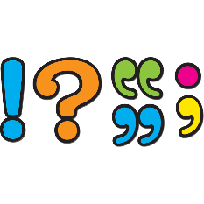
Literacy (Press F7 to check spellings and grammar)
What other literacy issues have you identified? ( Capital letters, punctuation and sentence structure)
All issues should be typed below (purple font)

