Target for this cycle Choose an item.
Name: Click here to enter text.
Compression
What is lossy compression?
What is lossless compression?
When would you use lossy compression?
When would you use lossless compression?

Exam Questions:
Assessment

 | 3
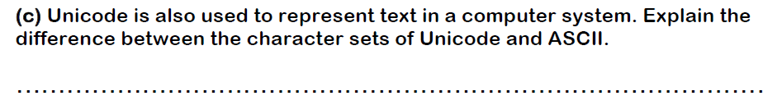 | 3
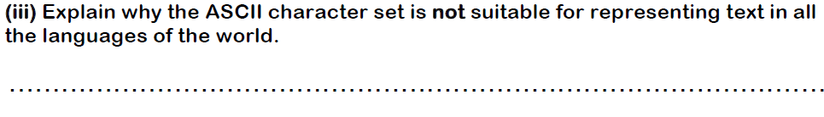 | 2
How many bits does the following string have? It is sunny.
What is the problem with Unicode?

Huffman coding
What is Huffman coding?
Why is it used?

Run Length encoding
What is Huffman coding?
Why is it used?

Translators
Assembler, compiler and interpreter
What is an assembler?
What is a compiler?
What is an interpreter?
What are two advantages and disadvantages of an assembler?
What are two advantages and disadvantages of a compiler?
What are two advantages and disadvantages of an interpreter?

