Name:Enter Your Name KS4 Target 1

What is an animated banner?
Explain what an animated banner is. Remember the importance of spelling, punctuation and grammar.
What is the purpose of a banner?
Add below websites you will put the banner on. | Explain why you chose each website (you need to consider your target audience which includes age, gender, interests and region.
What will you include that is suitable for the target audience ? | What would not be suitable to include for your target audience?
What will you include that ensures the banner relates to your brand personality? | Explain reason for including this.
Assets – Add a print screen of each one below | Explain why you decided on each asset.

INDEPENDENT LEARNING
What challenge are you attempting? |  | Branson
Add a print screen of your animated banner here.

Self assessment
Good points | Areas for improvement
Peer assessment
Good points | Areas for improvement

Completed animated banner
Add a print screen of your improved animated banner here.

Justify the decisions you made for your banner.
Decision 1
Decision 2
Decision 3
Decision 4
Decision 5
If you have more time how could your banner have been further improved? Remember literacy is important, so proof read your work and make improvements to spelling, punctuation and grammar if necessary.

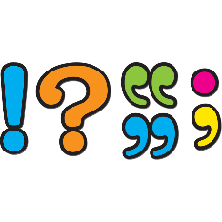
Literacy (Press F7 to check spellings and grammar)
What other literacy issues have you identified? ( Capital letters, punctuation and sentence structure)
All issues should be typed below (purple font)

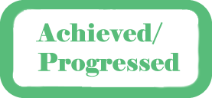
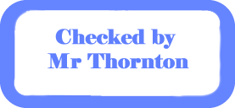

You will copy and paste these boxes to the correct section when instructed to do so by your teacher
Quiz score out of …

Quiz score out of …

Quiz score out of …
